THE NAVVY MISSION SOCIETY

Perhaps we can, in our mind’s eye visualize a small community in the quietude of the countryside being “invaded” by a hoard of strange men, outsiders, come to build a railway.

Imagine if you will, living in Calvert in the mid-1890s, Calvert as a village, even a hamlet, did not really exist as a nucleus.
Imagine if you will, living in Helmdon, a village of about 400 souls.
Imagine if you will, living in Brackley, a town with a population of two, maybe three thousand.

Suddenly, and it really was suddenly, hundreds of navvies, unknown outsiders descend on your little self-contained and, by modern standards, isolated community. These fit, hard-working, probably boisterous and strong men clustered in large groups are very intimidating even if always polite and well behaved. A real cross-section of men as they were must have frightened if not terrified most of the local community. Navvies were renowned for hard drinking, gambling, fighting and womanising.

By the time of the building of the Great Central Railway the worst of the excesses of the navvy were past as steam navvies (steam powered mechanical shovels) were employed on the heavier digging. However, the men certainly still worked incredibly hard even if in slightly reduced numbers.

As Great Central Railway was built there were missions built in most towns, villages and hamlets providing Sunday Schools and services.
Inside each mission there would be a rudimentary pulpit, a tortoise stove, a harmonium (pedal organ) texts on the walls and basic bench seats.

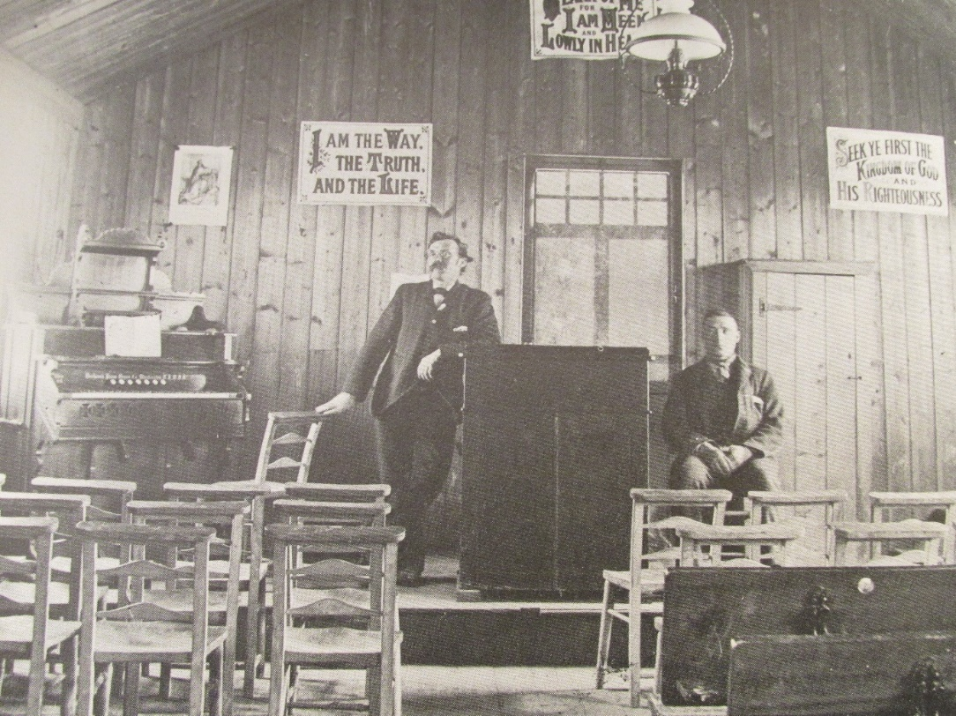
INSIDE A TYPICAL NAVVY MISSION HALL
This one was at Loughborough

In some cases, barns were utilized, in others wooden structures were hastily erected. In others, off the peg buildings were purchased and came in kit form with timber frames and cladding of corrugated iron. The Navvy Mission at Calvert is one of these latter and is in a format repeated along the line.

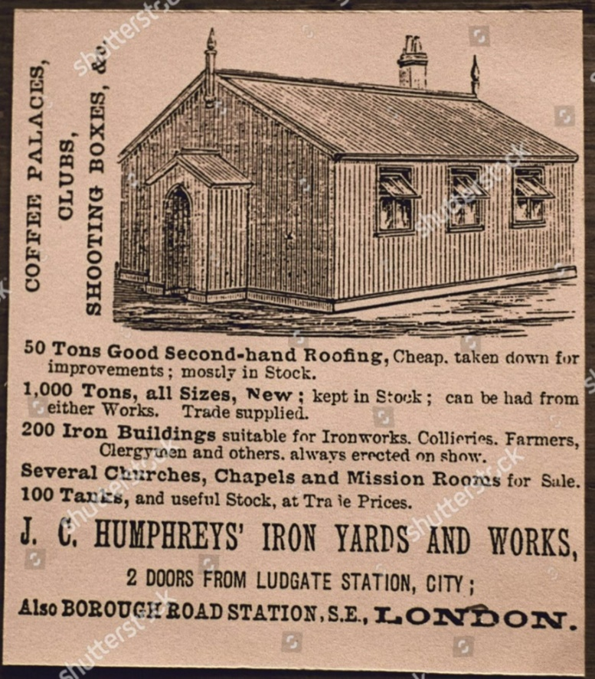

The Navvy Missioner was often a lay person, sometimes one who had himself been a navvy. Few were ordained men, however, by the time of the construction of the Great Central Railway it is my opinion that there were rather more ordained ministers. One such ordained man was Fred Bone of County Durham who ran the Navvy Mission at Helmdon. He married a Helmdon girl, Jane Spiers “Ginnie” Gibbons. He must have been in training for, with the completion of the Great Central Railway he was ordained in 1899. Strangely, Rev. Bone is buried in Helmdon churchyard whereas “Ginnie” is buried in London at the church where he became vicar. The explanation may lie in the fact that Rev. Bone died aged 42 and one must assume that “Ginnie” continued to live in London, possibly with a view to return to Helmdon.

Often the Navvy Missioner had to demonstrate his skill with pick and shovel to earn the respect of those to whom he was to minister. The missioner would move among the men and give out Bibles, not only to navvies but in the villages too. The missioners visited the sick and injured and arranged social activities. Missions were often well attended both by children in the Sunday School but also by the adults and, where the missions were at their best, it became apparent that the worst excesses of navvy rowdyism did diminish.

What has every appearance of being the Navvy Mission Hut at Calvert still stands. As there was no community as such at Calvert in the 1890s one must assume that the Mission served the navvies of the surrounding area.

This Mission Hut itself is a testament to the desire of local people to help the spiritual and moral welfare of those pioneers who built the infrastructure of our country. Paid for by local subscription these buildings are a remarkable reminder of those unsung heroes who built the country which once led the world in engineering prowess.

CALVERT NAVVY MISSION HALL
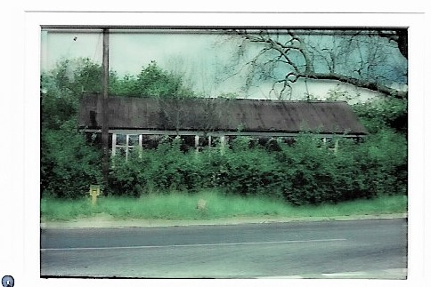
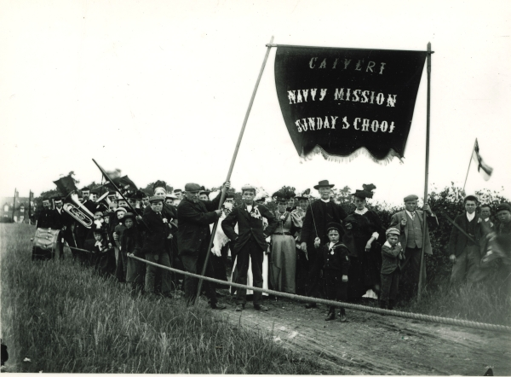

COMPLETE WITH BRASS BAND, A VERY WELL ATTENDED CALVERT NAVVY MISSION SUNDAY SCHOOL.
The Minister is an ordained man, visible centre front behind the small boy.

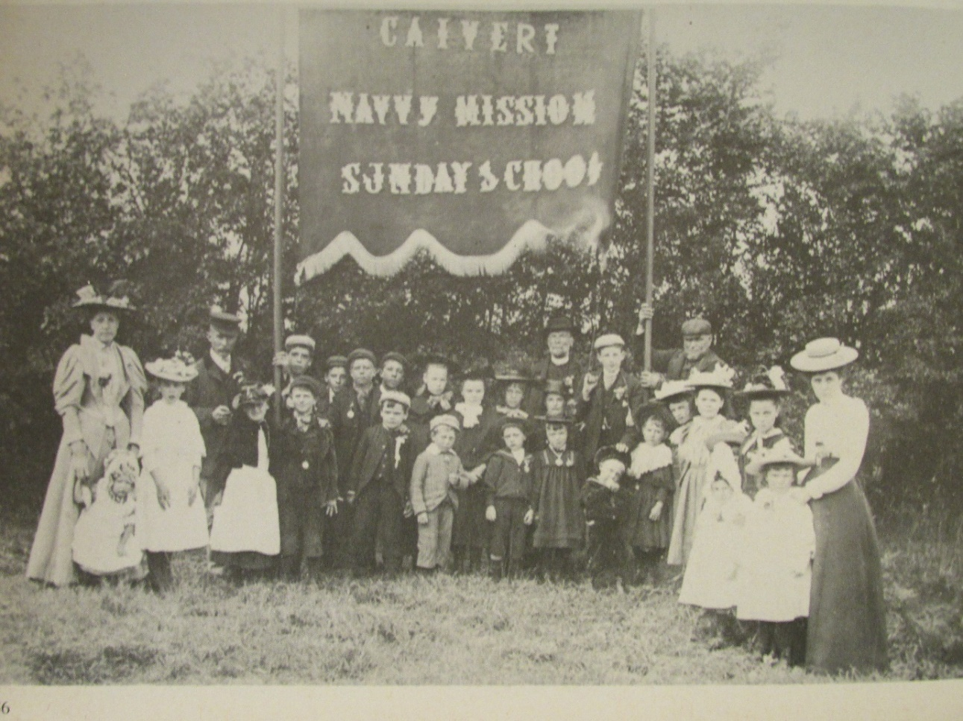
THE SUNDAY SCHOOL, CALVERT.
A WELL TURNED OUT GROUP WITH NAVVY MISSIONER.

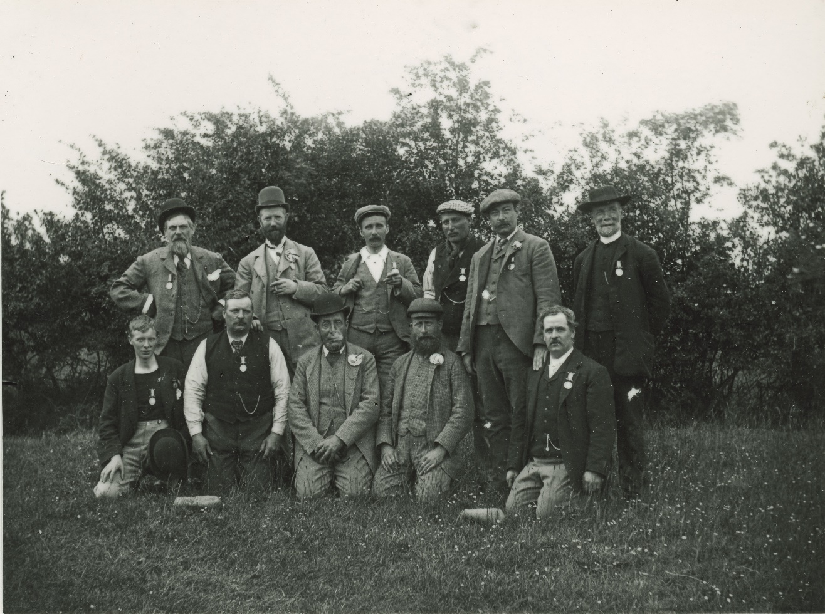

NAVVY MISSIONER WITH NAVVIES WEARING PERHAPS
CONDUCT OR ATTENDANCE ROSETTES AND MEDALS.

